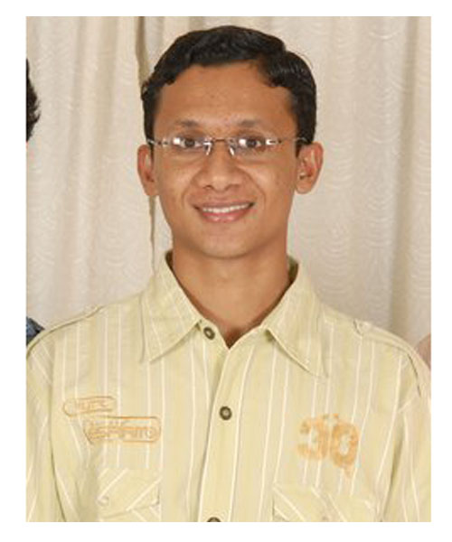

Name: **Joel Shajan**

Date of Birth: 01.03.1987

Height:5.7

Education Qualification:B.Tec In Electronic & Communication From

Mar Baselios College of Engineering and Technology Trivandrum

M.B.A In Marketing From Goa Institute Of Management

Designation: Emassco Agro Pvt limited-----Director

Thayillam paints--------------- Manager  
Religion: The Pentecostal Mission (TPM)

Father: shajan Abraham

Proprietor: Thayillam paints Trivandrum -ulloor,Vazhuthakkad,vanchur,karamana)

Managing director:Emasco Agro PVT LTD-cherthalla

Managing partner:Thayillam Kitchens & interiors Trivandrm-ulloor

Mother:Minee shajan

House wife

Proprietor: Bannatone Food Products-Kochuvelli

2 younger Brothers:

1.Job Shajan---MBBS 3rd year Jubilee Mission Medical college—Thrissur

2 .Josh Shajan—Plus two—St.ThomasCentral school Trivandrum

Preferance:Same Cast, non ornaments,CA/ICWAI,MBA in finance in reputable UTY

Fathers Background: Business Preferred

District: Tvm to Ernakulam Preferred.